1. Connecting to Data:

Data: National_Estimates.xlsx

Objectives:

Connecting to excel file

Use Data Interpreter

Exploring Metadata

Filter the source data

Split the columns

Live connection vs Data Extract

How to:

1. Connecting to excel file:

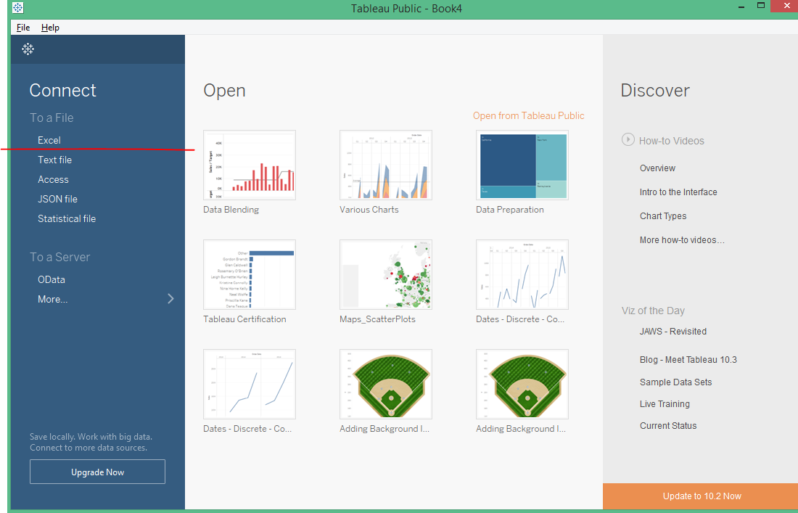

1. Before using Data Interpreter

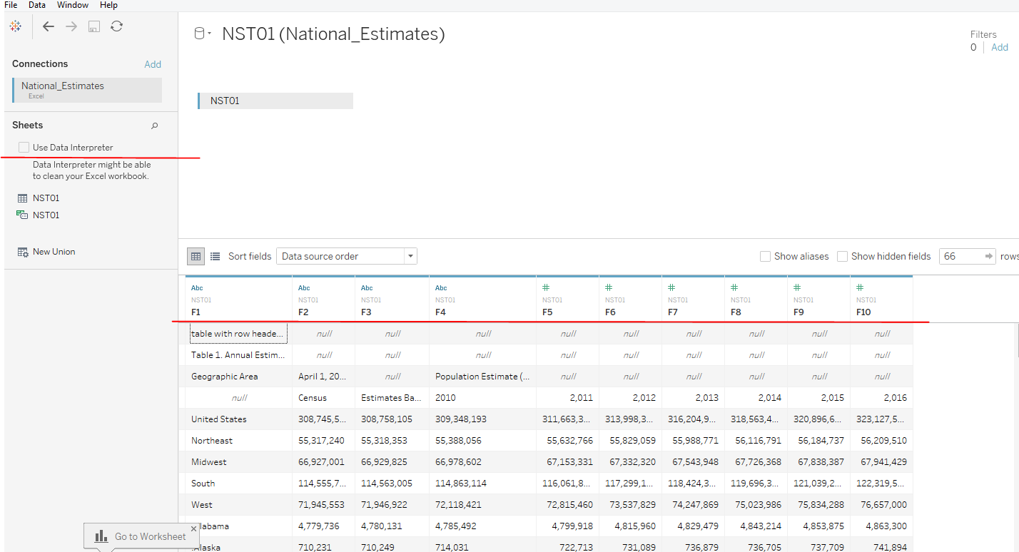

1. Check Data Interpreter

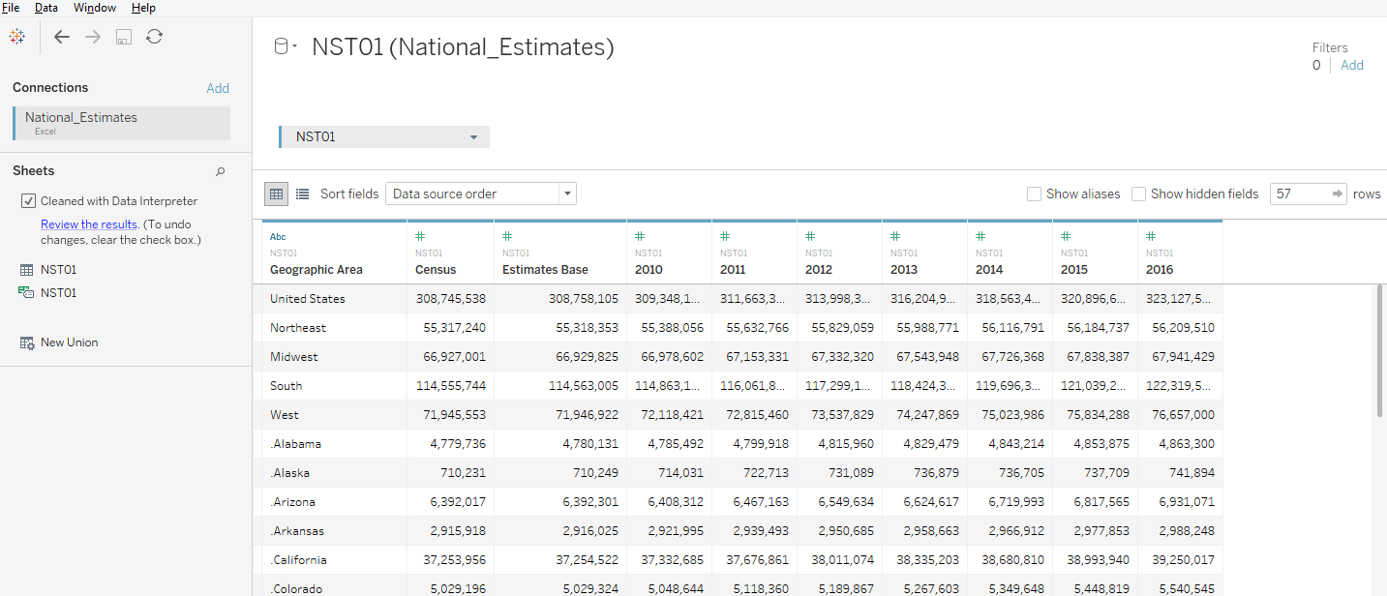

1. Hide Columns

Right click on “Census” and click “Hide”

Right click on “Estimate Base” and click “Hide”

1. Filtering Data
   1. Click on “Add” under “Filters” on top hand right corner

Exclude the following:

Midwest

Northeast

Puerto Rico

United States

West

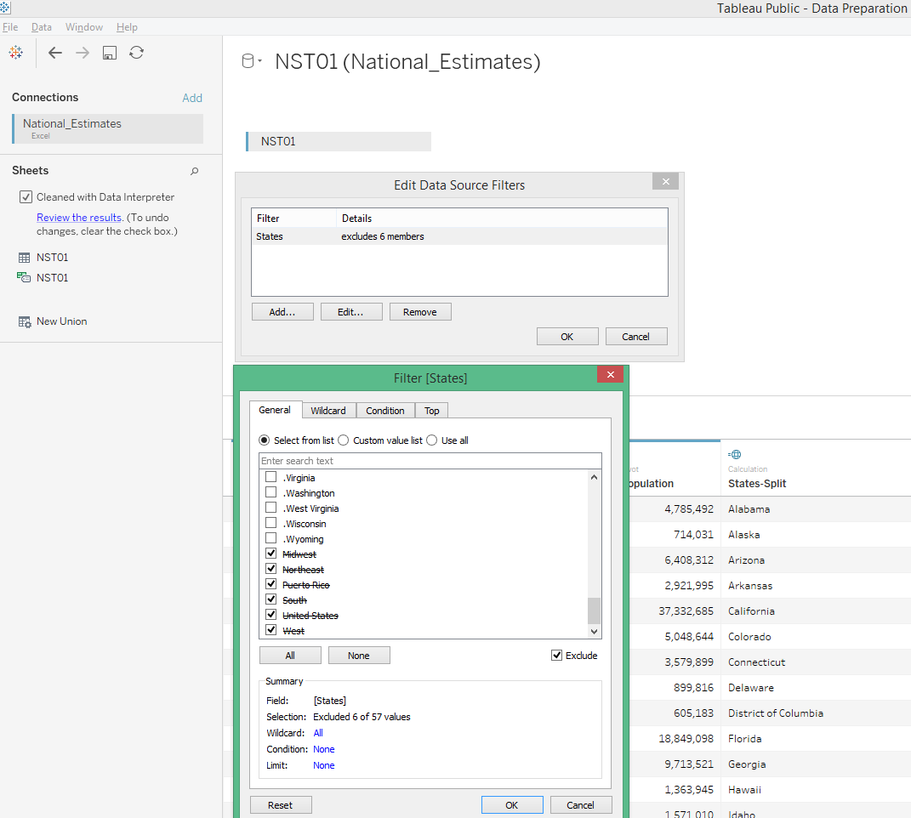

1. Right click on “Geographic Area” and click on “Split”

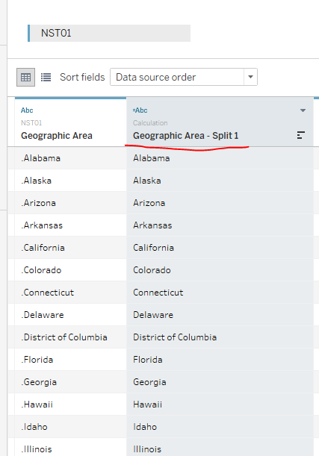

Rename “Geographic Area” as “States”

Rename “Geographic Area – Split 1” as “States Split”

1. Pivot
   1. Select columns - 2010 to 2012
   2. Right click and click “Pivot”
   3. Rename “Pivot Field Names” to “Year”
   4. Rename “Pivot Field Values” to “Population”

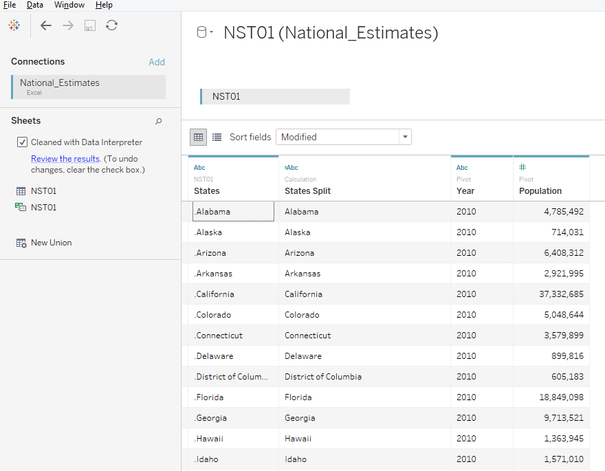

1. Can you “Hide” the column “States”?
2. Click on “Go to Worksheet”

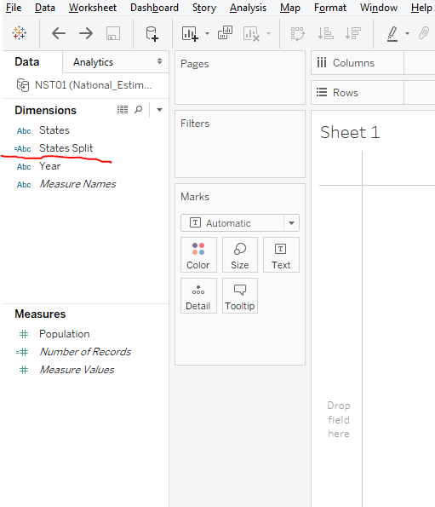

1. Change the role of “States”

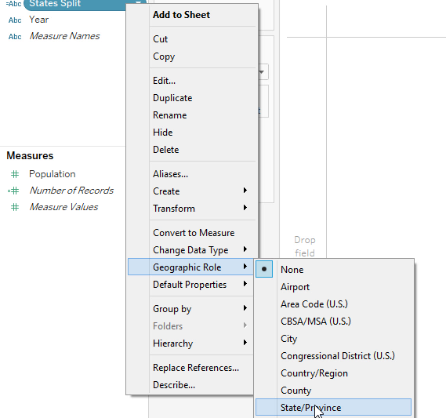

1. Observe the icon before the “States Split”

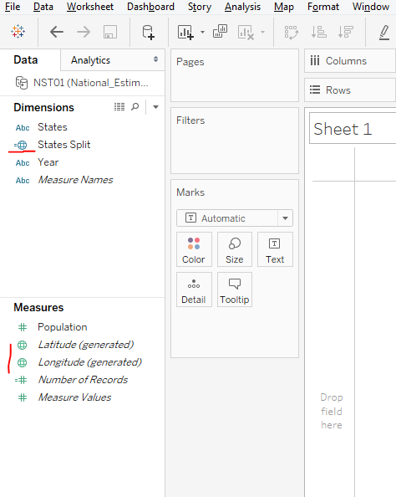

1. Observe the icon before the “States Split”
2. **Bar Chart – Top 10 States by Population**

How to:

* 1. Columns: States-Split
  2. Rows: Population
  3. Color: States-Split
  4. Filters: States-Split

Right click on “States-Split” and click on “Edit Filter”

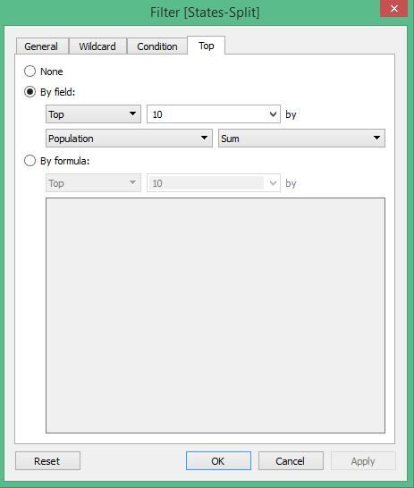

Click Ok

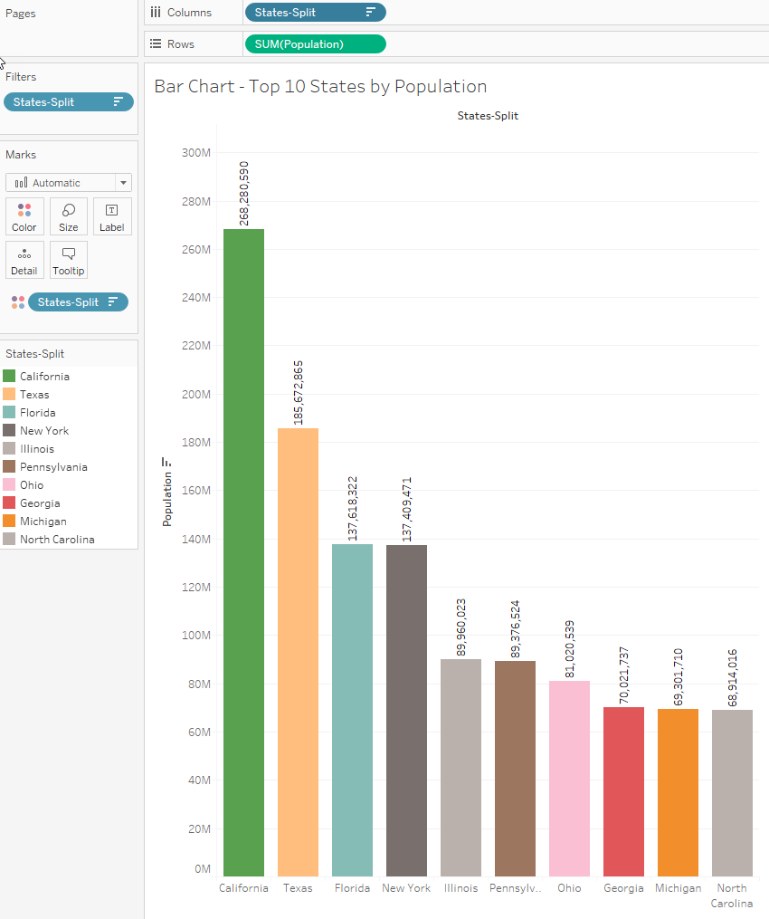

What’s wrong with the Bar Chart?

CA – 268 million?

Add “Year” to filter and select “2016”

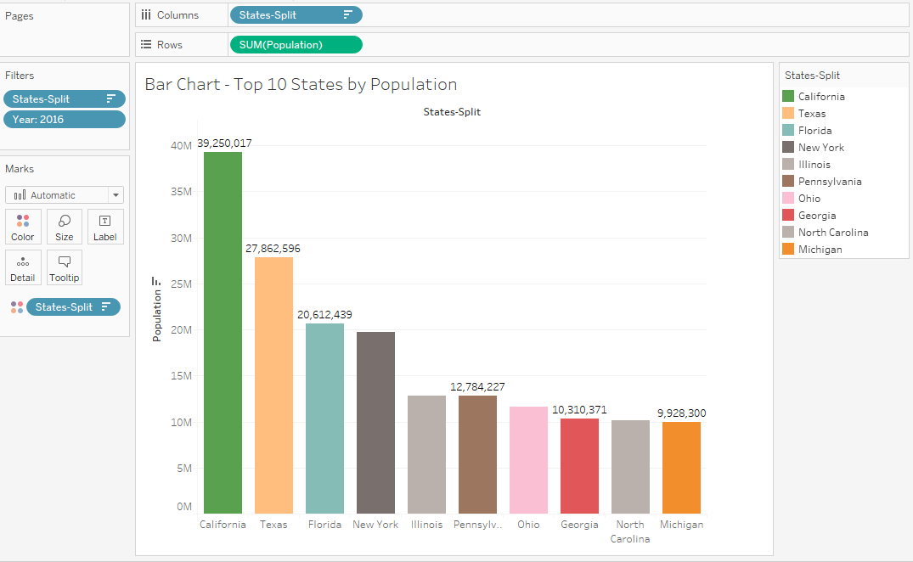

1. **How can we make number of States – Top 10 as Dynamic one?**

Create a Parameter: N Records

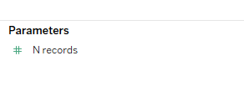

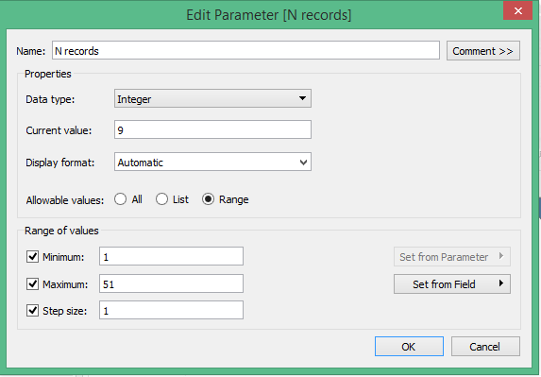

Filtering data by using a Parameter control:

Right click on “N Records” parameter and click on “Show Parameter Control”

Right click on “States Split” in Filters shelf, click on “Edit Filter”

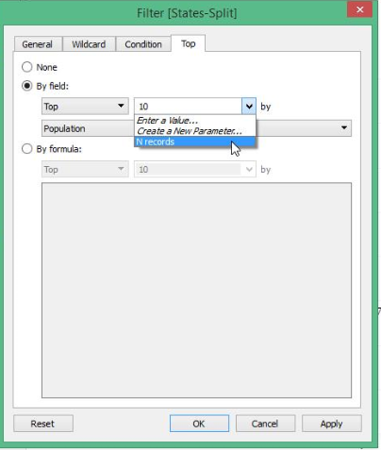

Select “N Records” in the drop down and click “Apply”

Move the slider control and observe the Bar Chart…

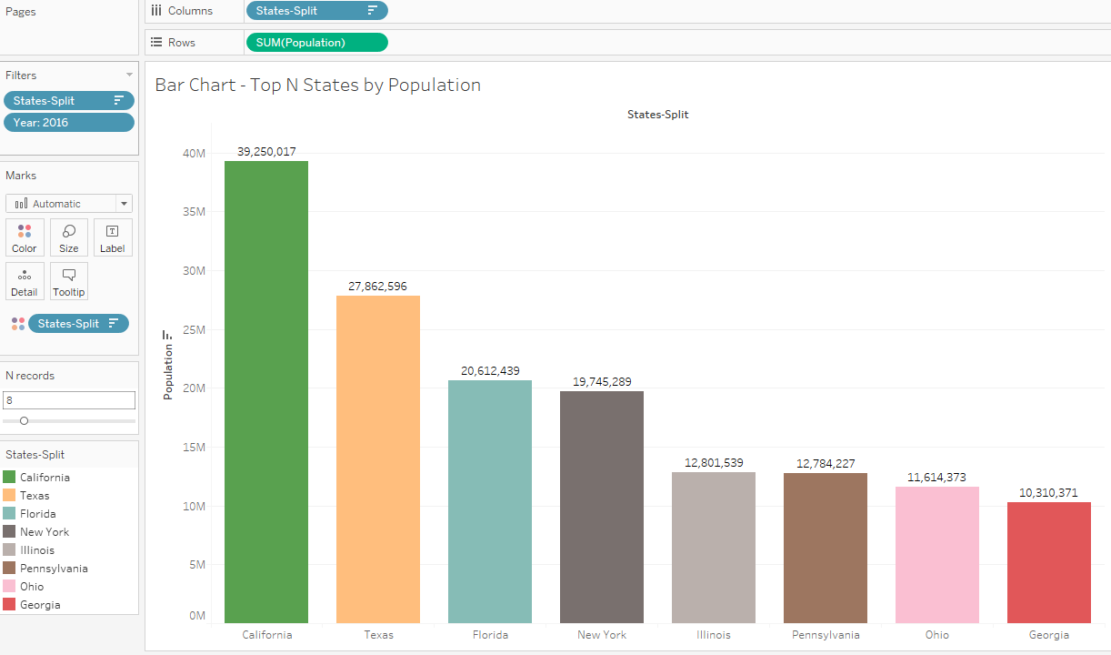

1. **Filled maps**

How to:

* 1. Detail: States-Split
  2. Color: Population
  3. Label: States-Split
  4. Label: Population

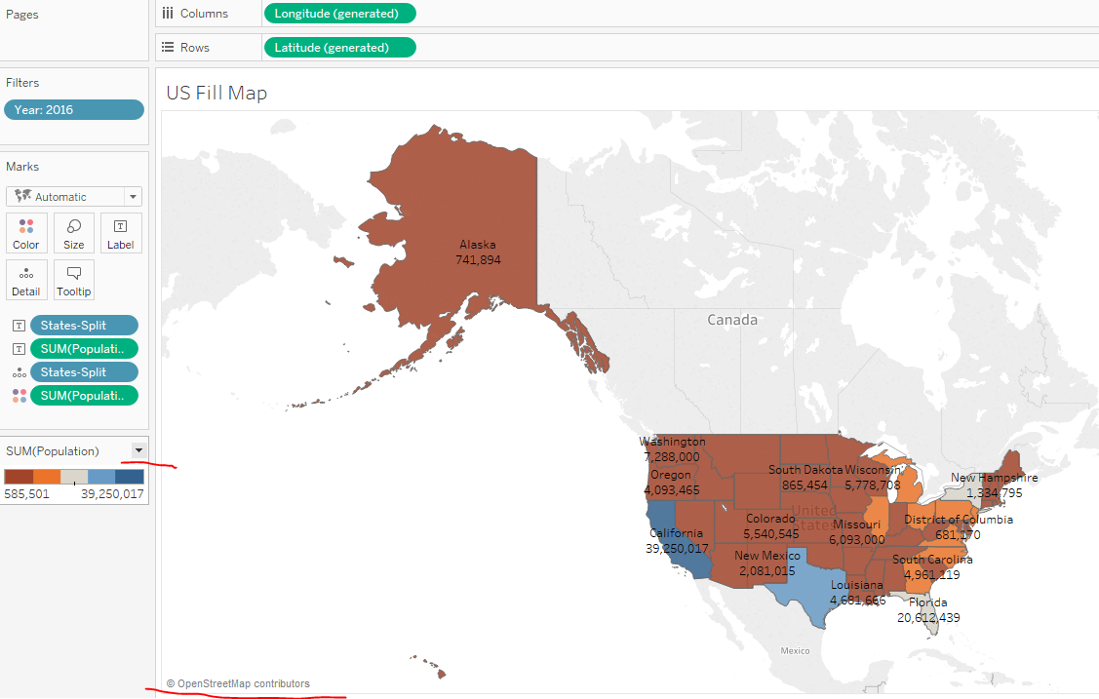

Tableau is using open source software to display maps

<https://www.openstreetmap.org>

click on drop down next to Sum(Population) and click on Edit colors

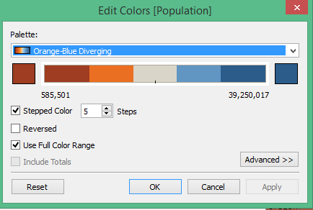

There are lot of variations in choosing the color.

Please read the following:

<https://www.tableau.com/about/blog/2016/4/examining-data-viz-rules-dont-use-red-green-together-53463>

<https://www.tableau.com/about/blog/2016/7/colors-upgrade-tableau-10-56782>

1. **Crosstab**

How to:

Right click on “US Fill map” work sheet and click “Duplicate as Crosstab”

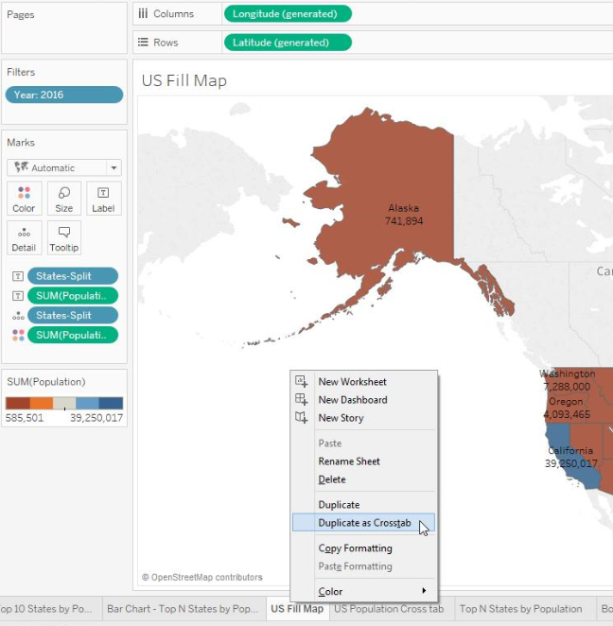

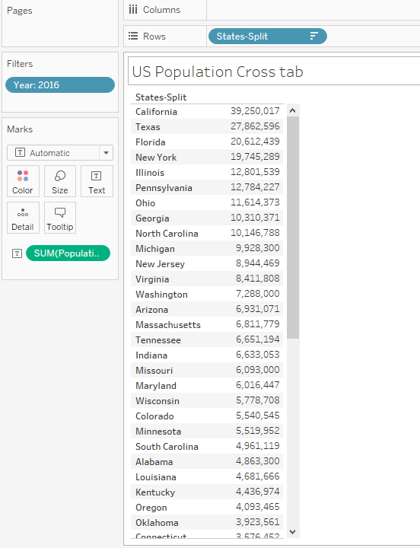

Crosstab is for displaying data in text format. If you want to see the data behind any Visualization, Crosstab is the answer.

1. **Can you apply a parameter – “N Records” to make the filler map dynamic**?

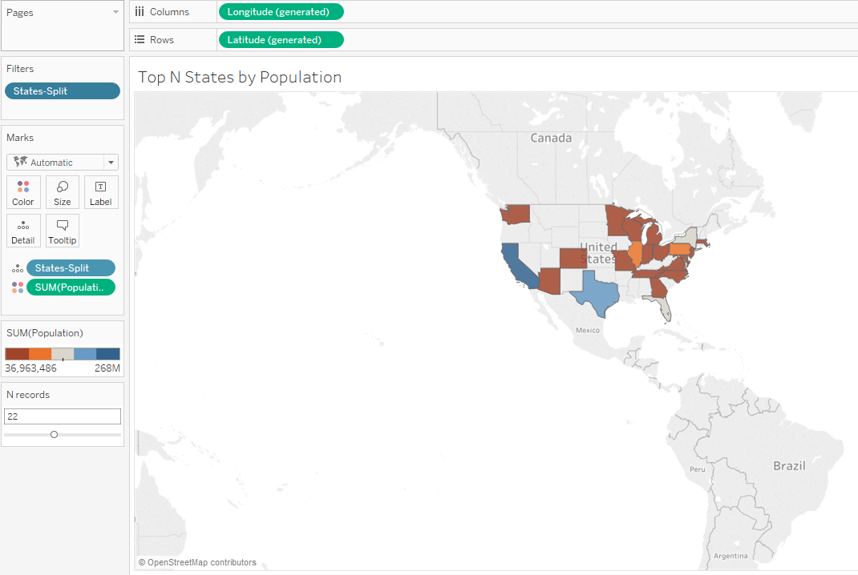

1. **Can you display a filled map with “Bottom” – N Records?**

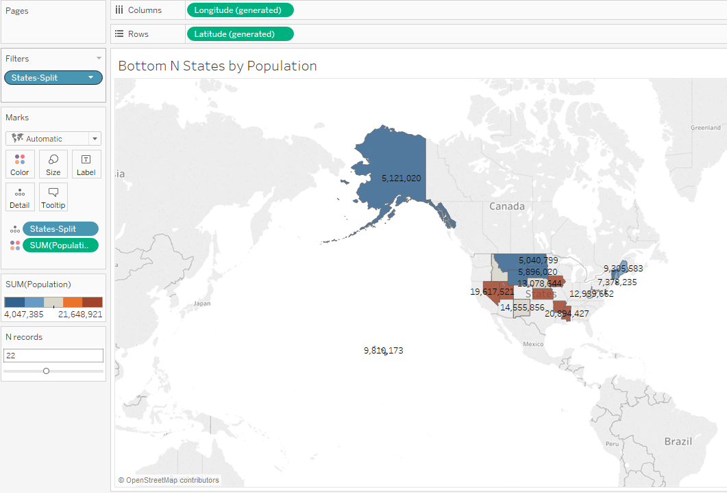

1. **Create Groups**

How to:

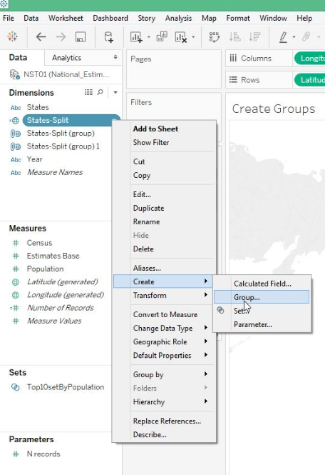

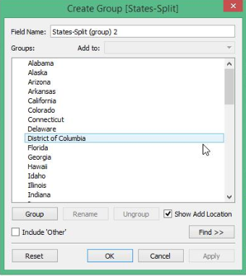

Select multiple states and click on “Group” button

Create the groups as follows: West, MidWest, NorthEast and South

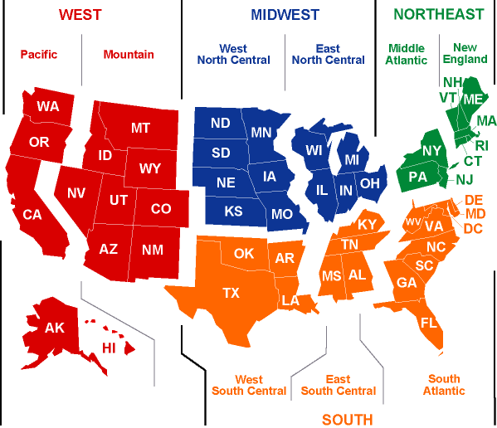

* 1. Detail: States-Split Group
  2. Color: Population

**NOTE:** Your View will not be the same as below. (Because, I haven’t created all the groups mentioned above)

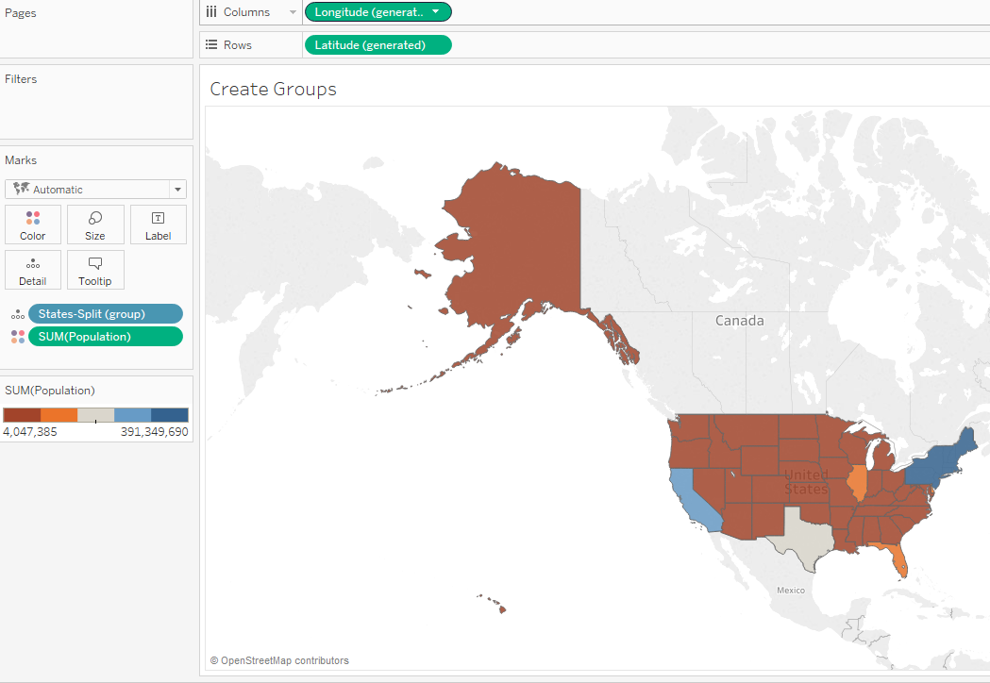

1. **Create Groups (Another way)**

How to:

Select states using a mouse

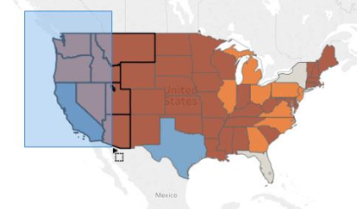

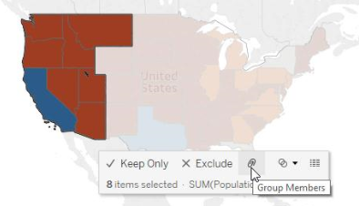

Click on Group icon.

Create multiple Groups.

You can rename the Groups by Right click “States-Split Group2”

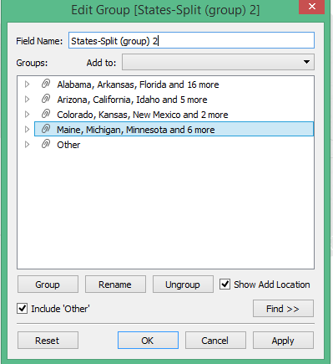

NOTE: Your View will not be the same as below. (Because, I choose the Groups randomly)

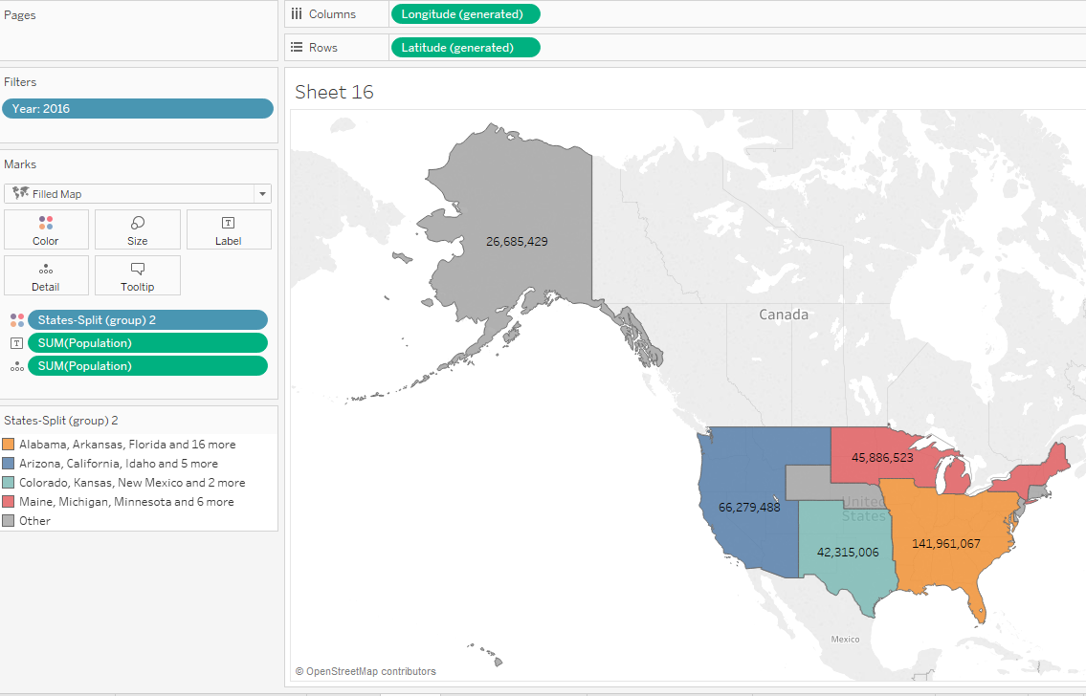

1. **HighLight tables**

How to:

1. Rows: States-Split
2. Color: Population
3. Label: Population
4. Marks: Square
5. Filters: States-Split

Edit the filter to display “Bottom N Records”

1. Click on “Show Me” and select highlight tables

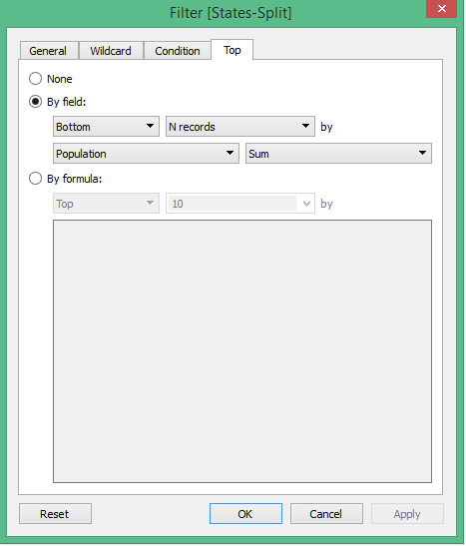

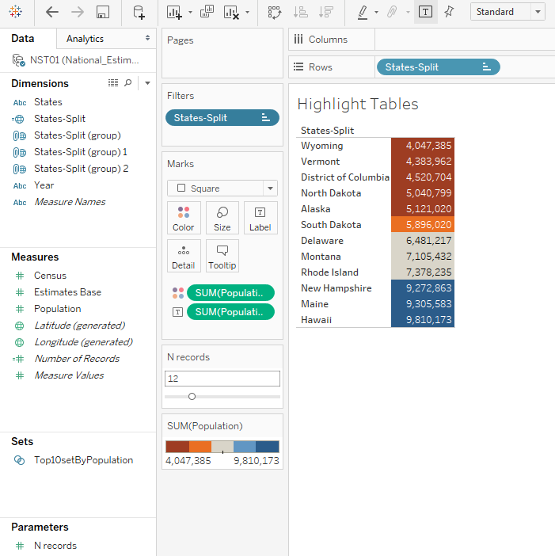

1. Treemap

How to:

* 1. Filters: States-Split
  2. Size: Population
  3. Color: Population
  4. Tooltip: Population
  5. Label: States-Split
  6. Label: Population
  7. Show parameter control: N Records
  8. Edit the filter as follows

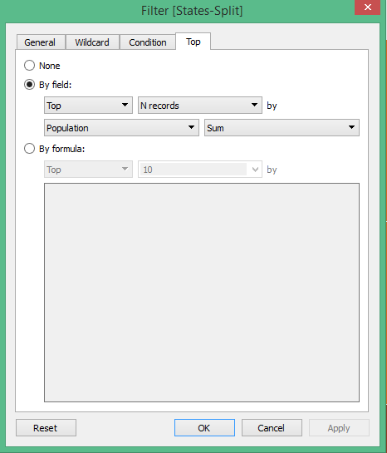

* 1. Show Me – Select Treemap

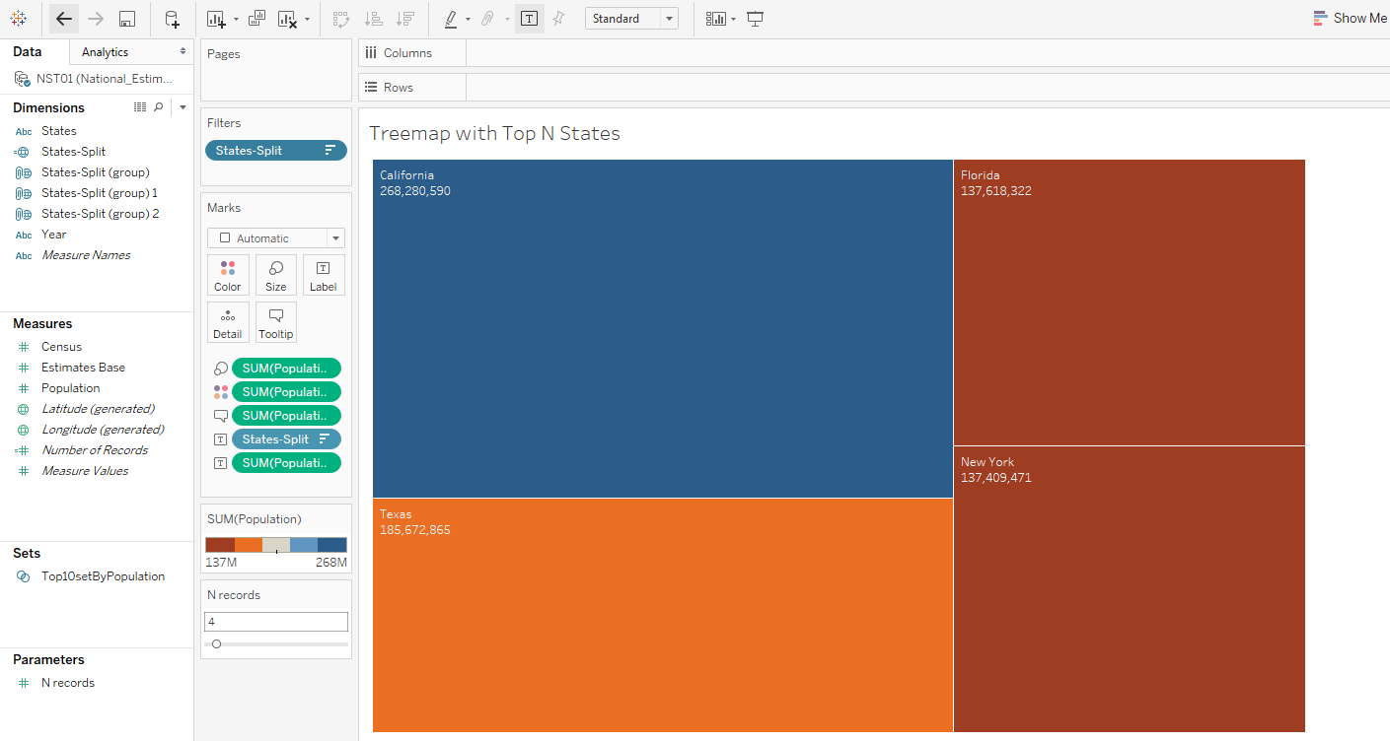

**Area Charts – Discrete**

How to:

1. Columns: Order Date (Discrete)
2. Rows: Sales
3. Filters: Category
4. Color: Category

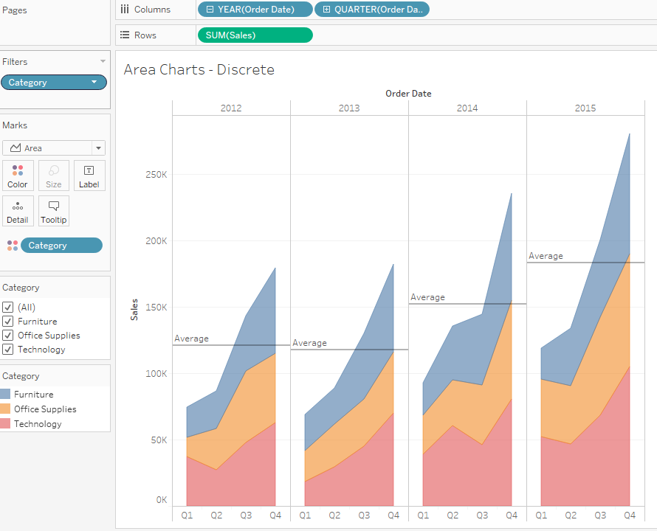

1. Add reference line:
   1. Table
   2. Pane
   3. Cell

What is the difference among the three?

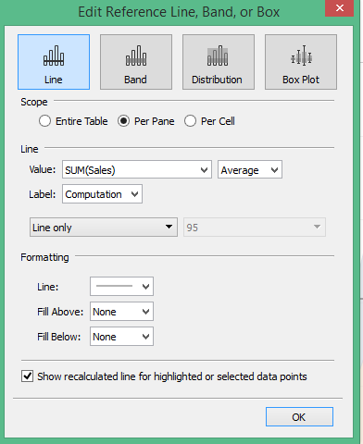

**Area Charts – Continuous**

How to:

1. Columns: Order Date (Continuous)
2. Rows: Sales
3. Filters: Category
4. Color: Category
5. Label: Sales

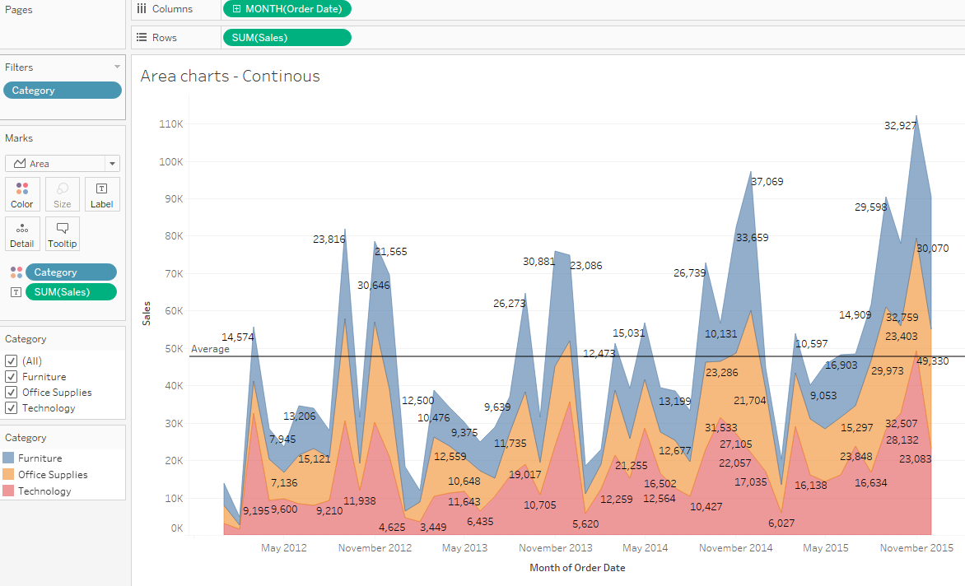

1. Add Reference line
   1. Table
   2. Pane
   3. Cell

What is the difference among the three?



**Dual Axis chart: Axis not synchronized**

How to:

1. Columns: Order Date (Continuous)
2. Rows: Profit, Sales (Observe the order)
3. Color: Measure Names

Observe the axis – They are not synchronized

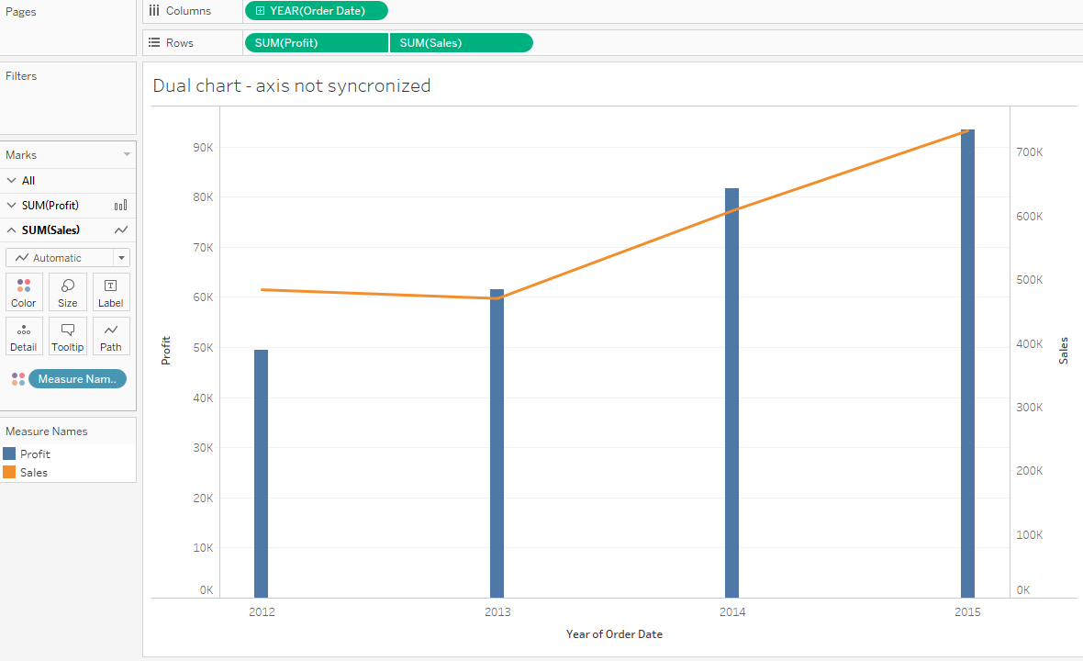

**Dual axis: Axis synchronized**

How to:

1. Columns: Order Date (Discrete)
2. Rows: Sales, Profit (Observe the order)
3. Color: Measure Names
4. Go to Menu: Worksheet -> Show Caption, Show Summary

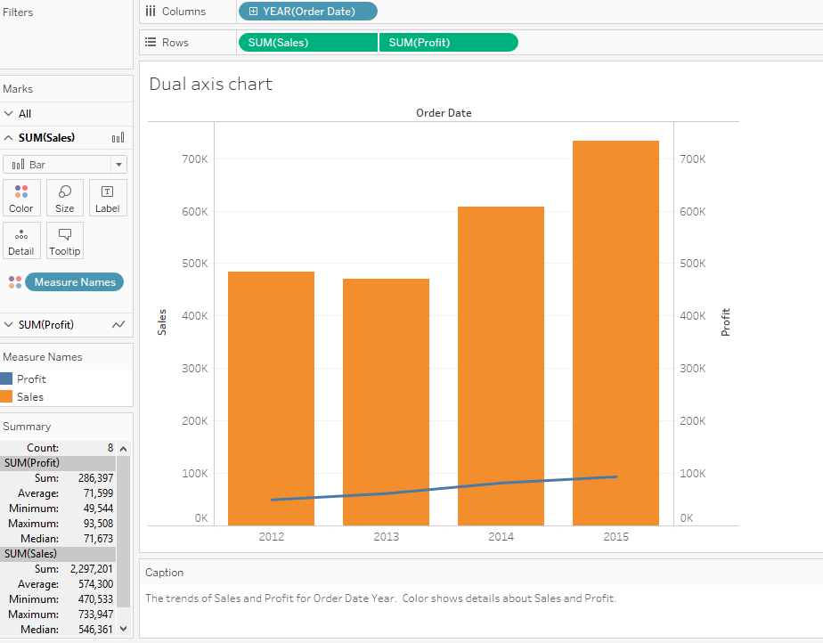

Dual Axis – Bar in Bar

How to:

1. Columns: Category
2. Rows: Sales, Profit
3. Color: Measure Names
4. Fit: Fit Width
5. Size: Adjust the width of each bar

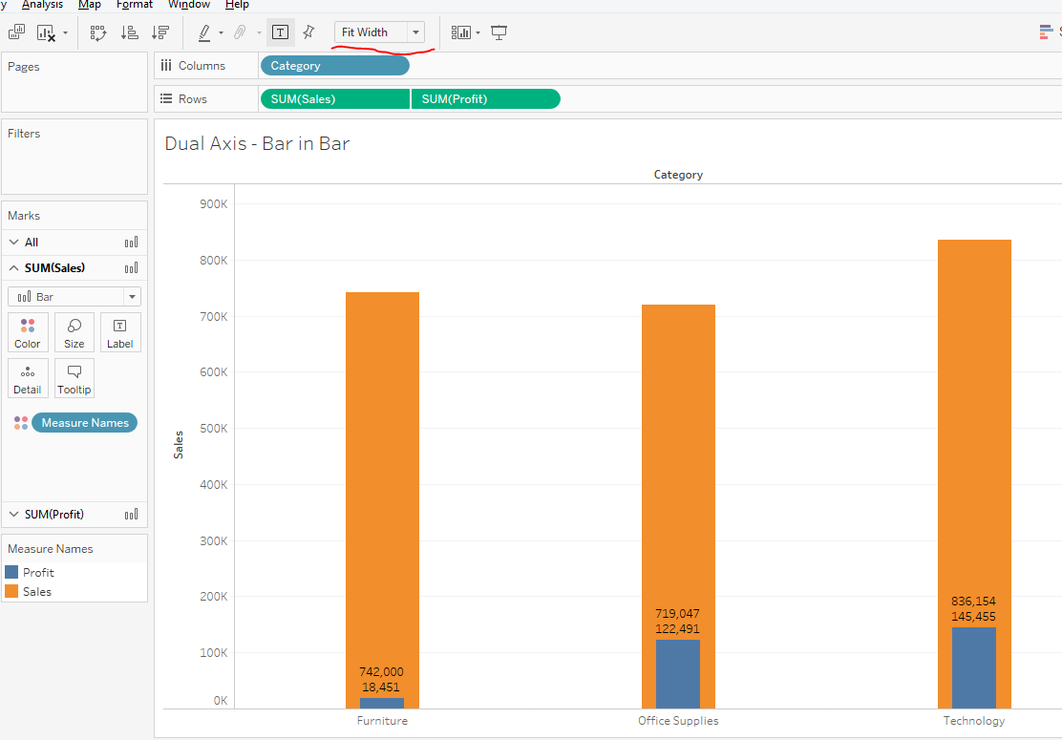

**Packed Bubbles:**

How to:

1. Create a parameter: CutOffAmount

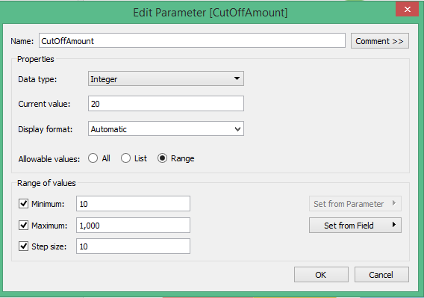

1. Create a calculated field

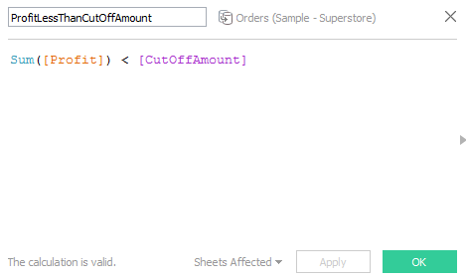

This field will create a T/F field

Similar calculated field but static calculation

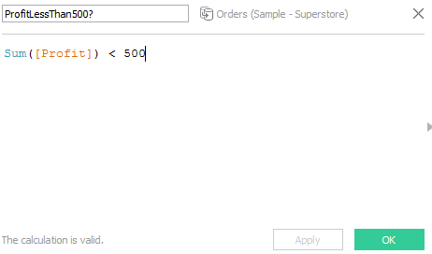

1. Size: Profit
2. Color: Customer Name
3. Label: Customer Name
4. Filters: ProfitLessThanCutOffAmount
5. Right click on “CutOffAmount” parameter and click on ‘Show Parameter Control’
6. Set the “CutOffAmount” slider to 20

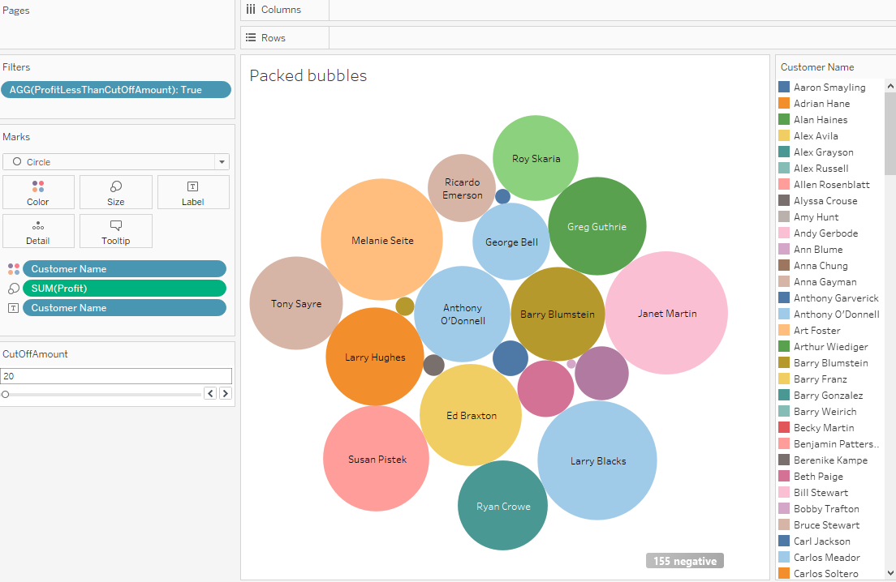

**Circles:**

How to:

1. Columns: Category
2. Rows: Sales
3. Color: Category
4. Label: Sales
5. Shape: select filled circle (Multiple options)

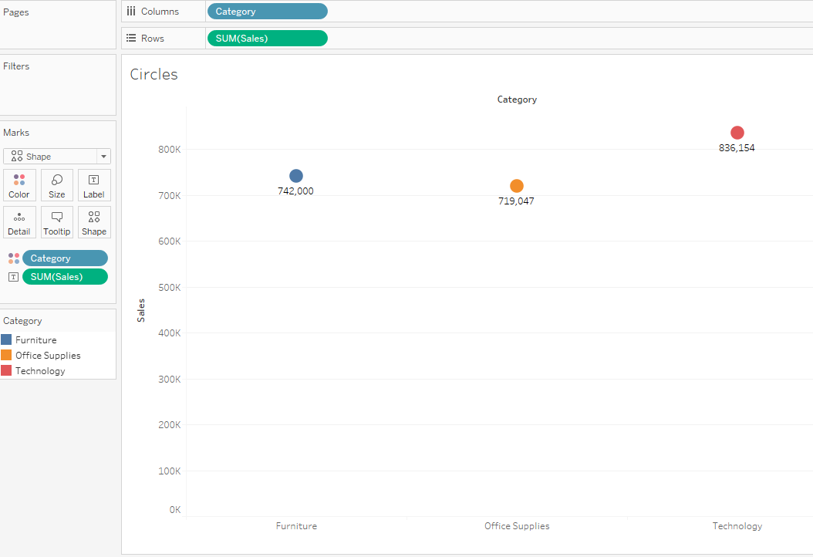

**Side-by-Side Circles**

How to:

1. Columns: Category, Sub-Category
2. Rows: Sales
3. Color: Sub-Category
4. Shape: Circle

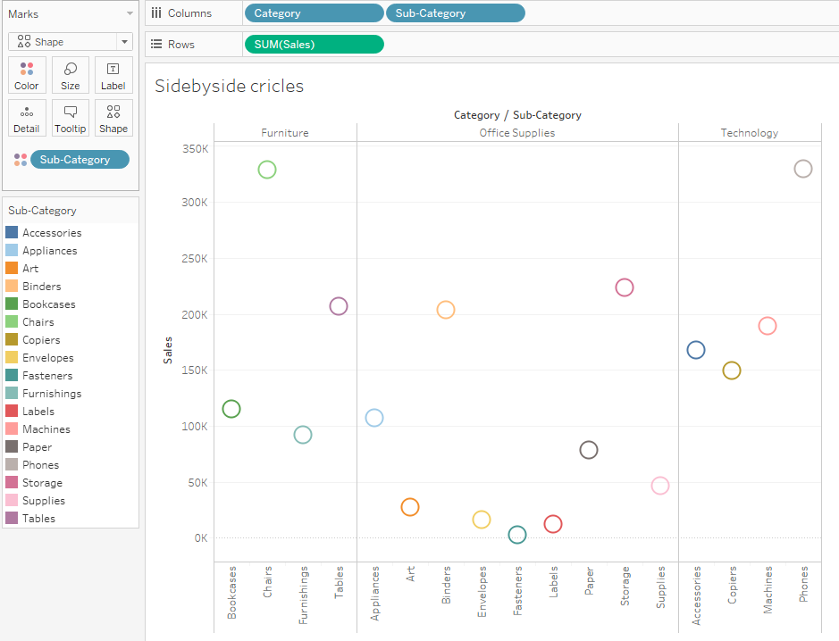

**Heat maps:**

How to:

1. Rows: Category, Sub-Category
2. Color: Category
3. Size: Sales
4. Label: Sales

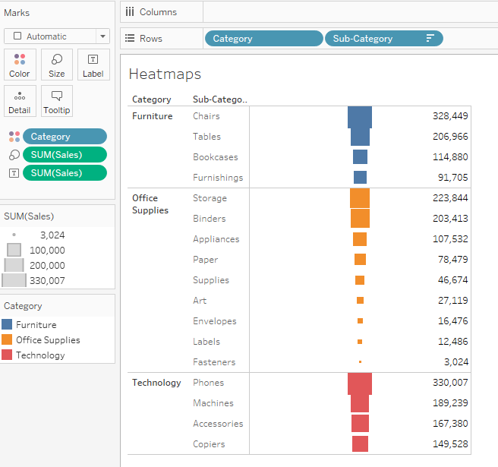

**Aggregate:**

How to:

1. Calculated field

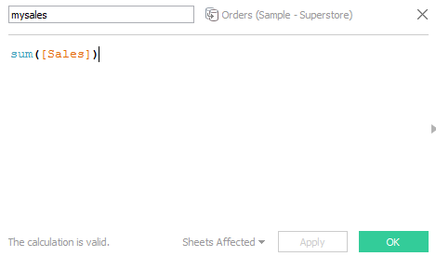

1. Columns: Category
2. Rows: mysales, Sales
3. Color: Category

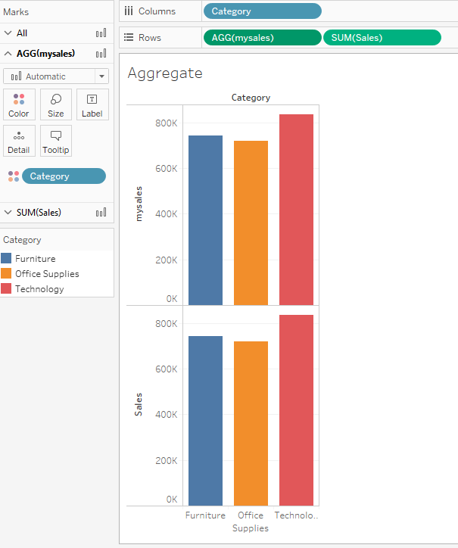

1. What is the difference between: mysales and Sales? They are displaying the same data
   1. Right click on mysales and Sales – one at a time and see the difference in options
   2. Observe that “mysales” aggregations cannot be changed, because it is already an aggregated field

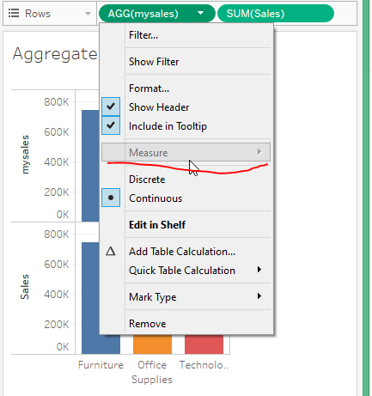

* 1. You can change the aggregation of “Sales”

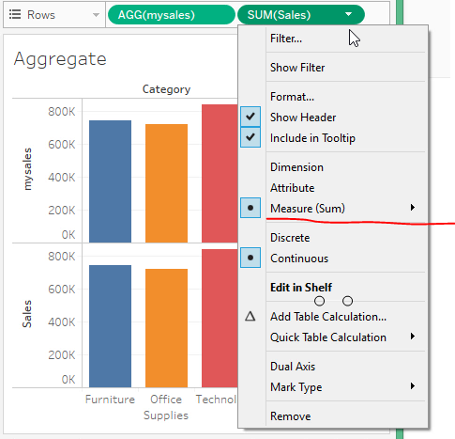

**Scatter Plot:**

How to:

1. Calculated field
   1. ProfiRatio

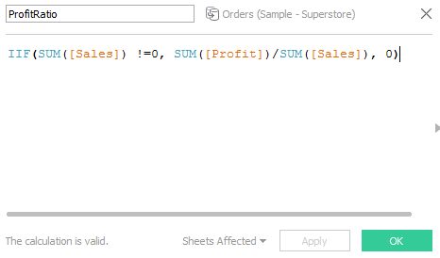

1. Columns: Profit
2. Rows: ProfitRatio
3. Color: ProfitRatio
4. Label: Sales
5. Label: Profit
6. Menu: Analysis -> Uncheck ‘Aggregate Measures’

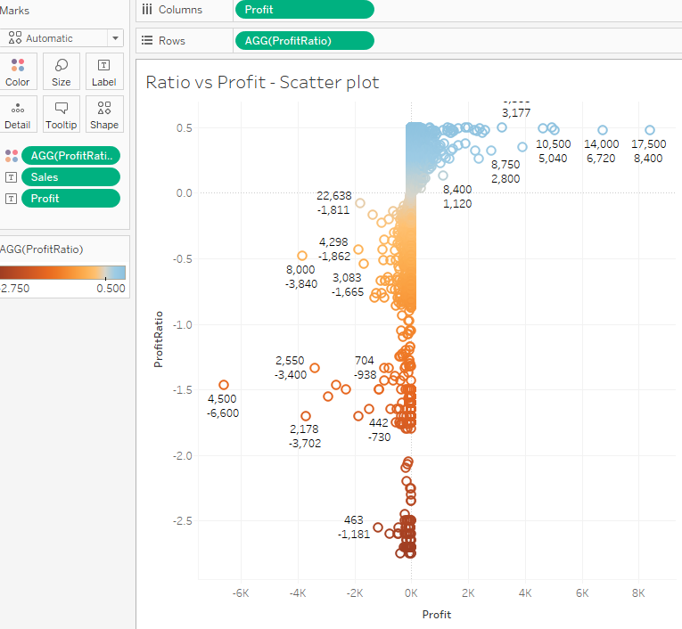

Alternate version: Different marks

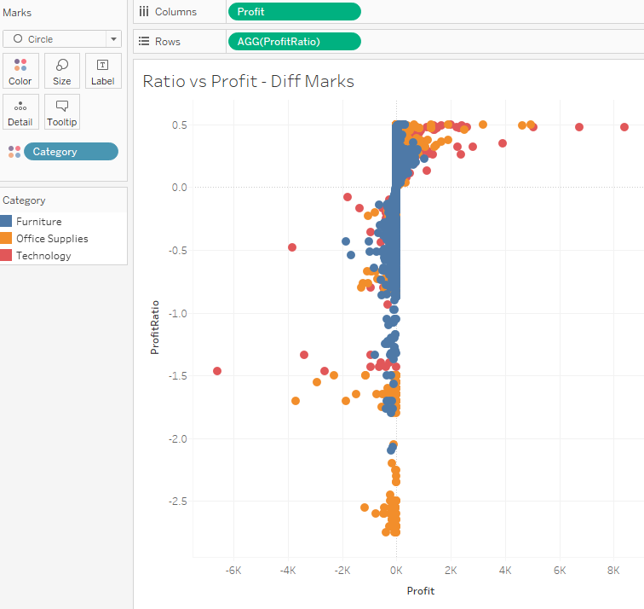

**Difference between Groups and Sets:**

1. Sets can only be created using Dimensions but not using Measures
2. Groups can be created using Dimensions as well as Measures
3. Sets cannot be created using Calculated fields but can be used in calculated fields
4. Groups can be created using Calculated fields but groups cannot be used in Calculated fields

**Sets, Combined Sets**

How to:

1. Creating a set
   1. Right click on ‘Customer Name’ and click ‘Create’ and click on ‘Set’
   2. Top 10 Customers by Sales

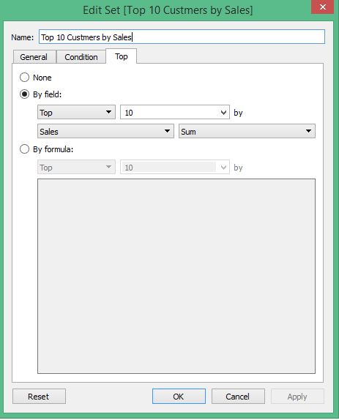

1. Bottom 10 Customers by Sales

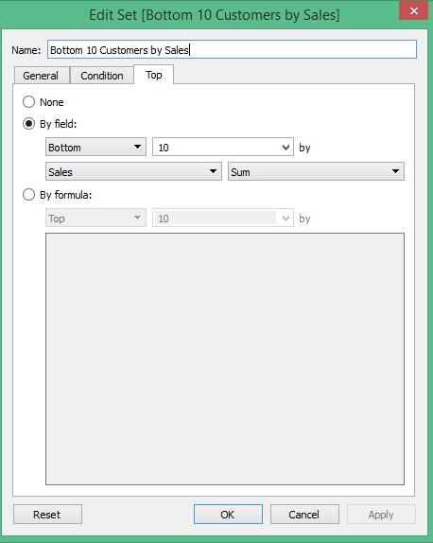

1. Create a combined set
   * 1. Right click on ‘Top 10 Customers by Sales’ and click ‘Create Combined Set’

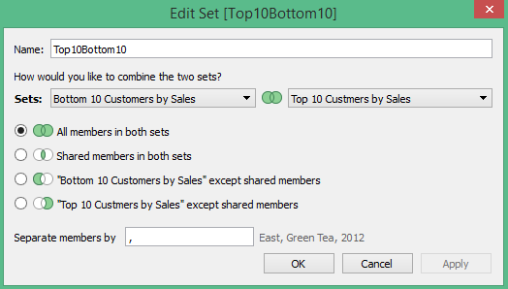

Observe the various options to combine the sets

1. Columns: Sales
2. Rows: Customer Name, Top10Bottom10 (Combined Set)
3. Filters: Top10Bottom10
4. Color: Sales
5. Label: Sales

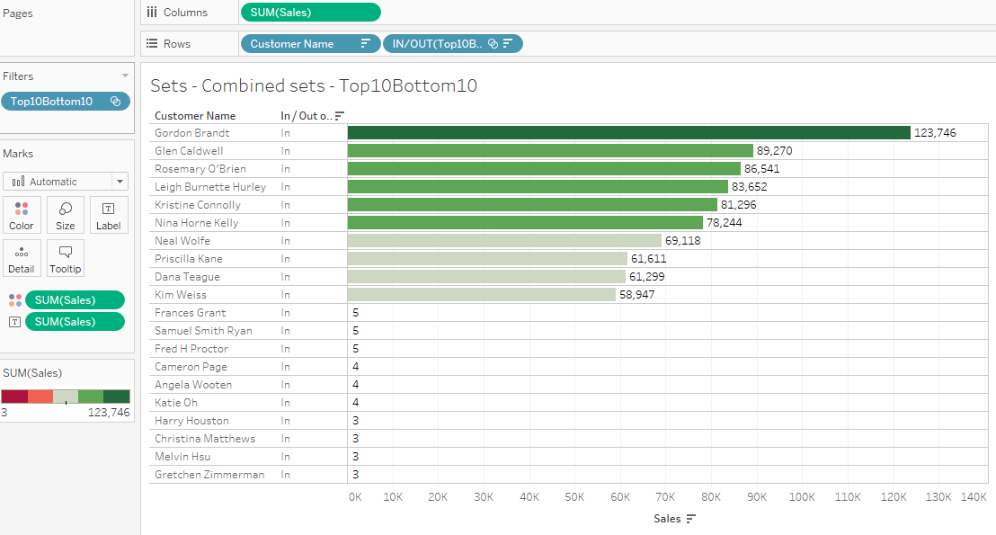

Difference between Filters and Sets:

Filters are specific to the worksheet

Sets can be reused on multiple worksheets

**Dynamically display Measures**

How to:

1. Create a parameter: ‘Select Measure’

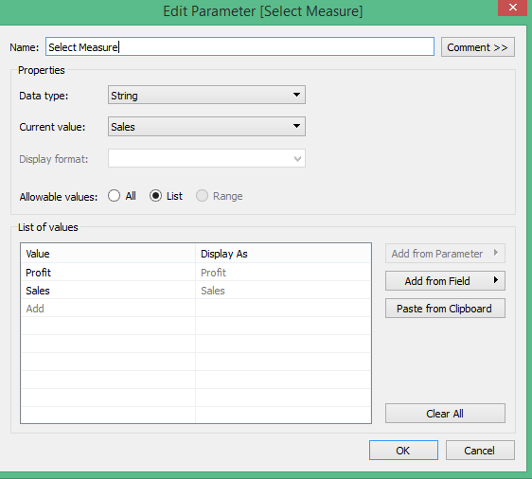

1. Create a calculated field

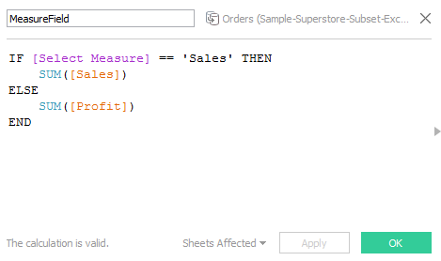

1. Columns: Product Category
2. Rows: Measure field
3. Color: Product Category
4. Right click on “Select Measure’ and select ‘Show Parameter Control’

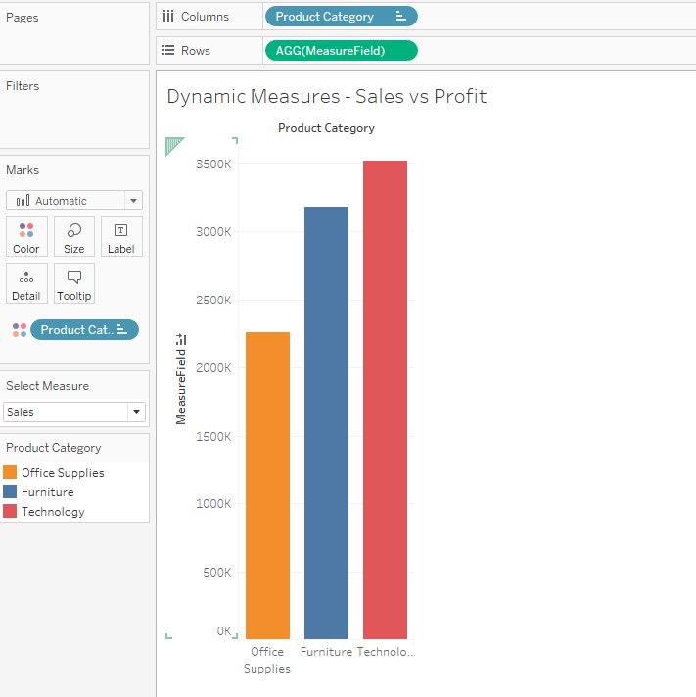

1. Change ‘Select Measure’ option to ‘Profit’ and the Bar chart will be updated

**Forecast Sales:**

How to:

1. Columns: Order Date(Continuous)
2. Rows: Sales
3. Color: Product Category
4. Show Me: Lines (Discrete)

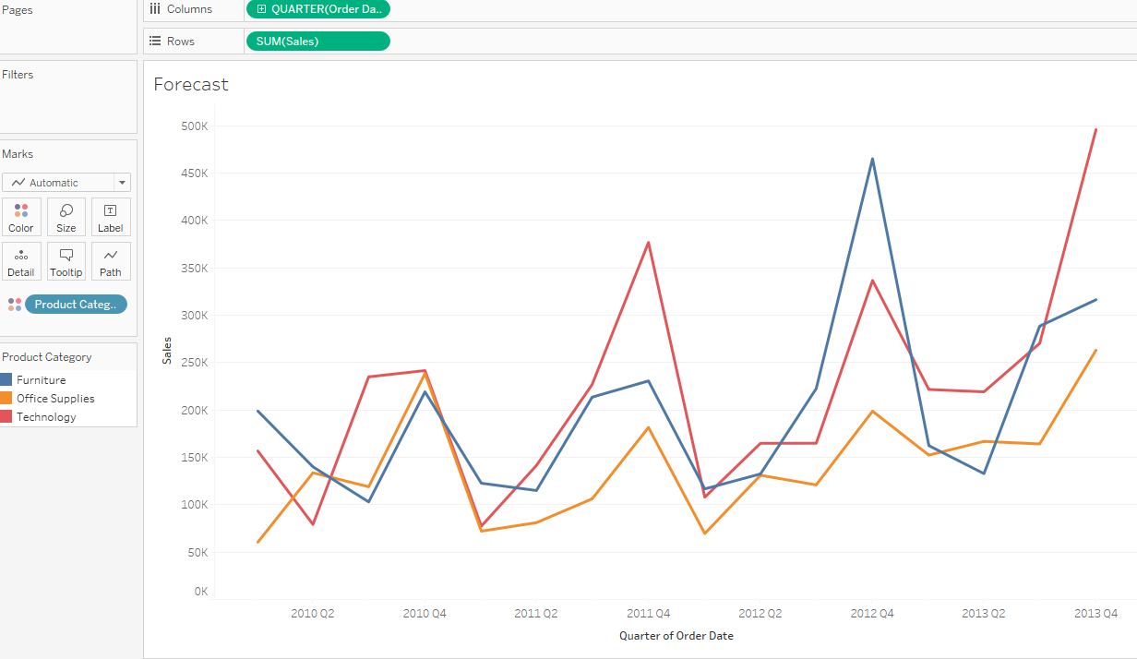

1. Click on Analytics
2. Drag ‘Forecast’ to View

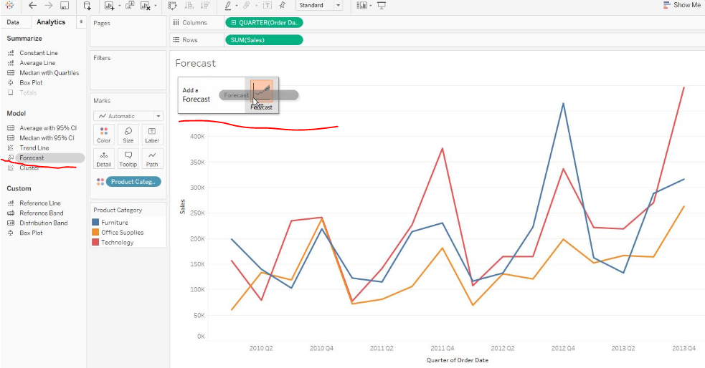

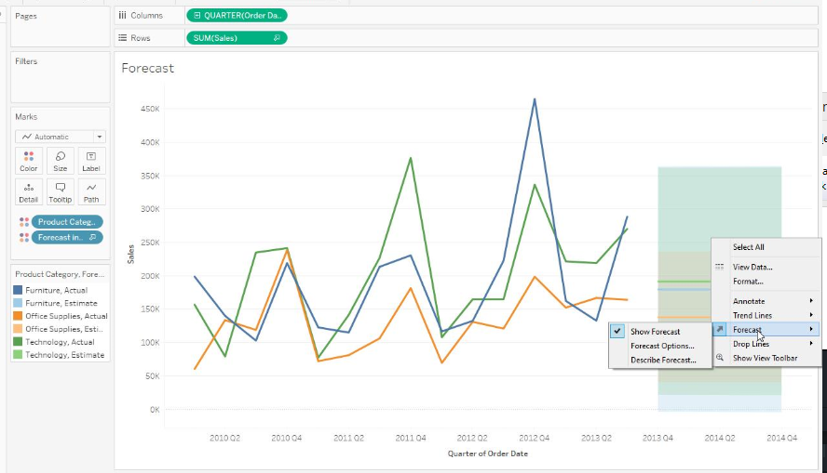

1. Remove ‘Forecast’ on Color
2. Right Click on highlighted area
3. Click on ‘Forecast’ and click on ‘Forecast’ options

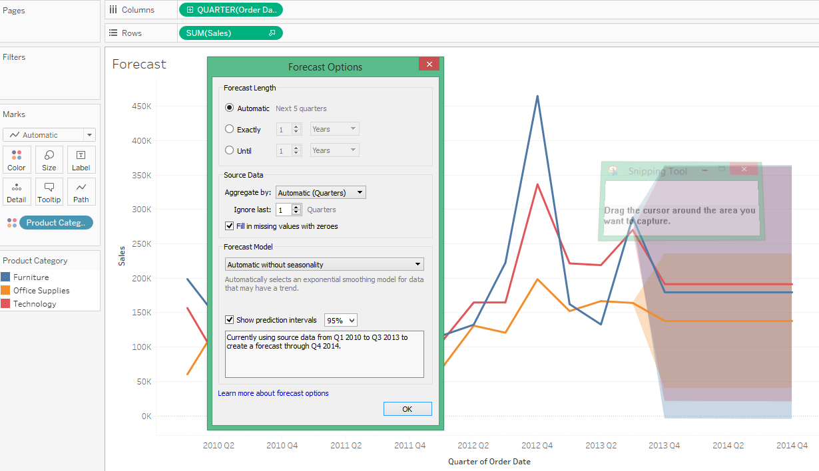

1. Describe Forecast

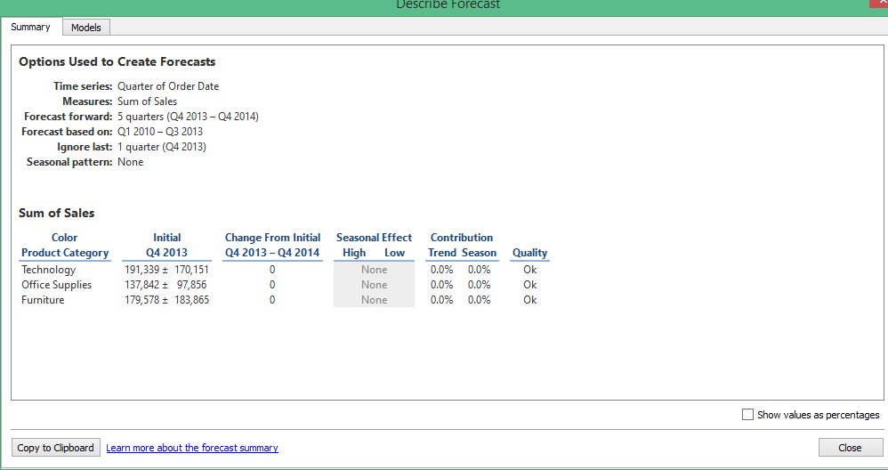

1. Right click on highlighted area and explore rest of the options

**Sorting using Legends:**

How to:

1. Columns: Category
2. Rows: Sales
3. Color: Ship Mode

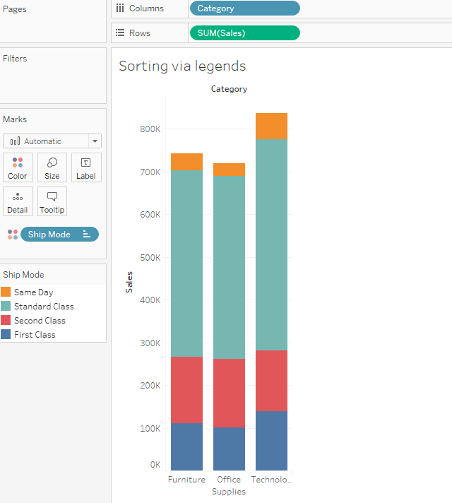

1. Rearrange legend as follows
   1. Same Day
   2. First Class
   3. Second Class
   4. Standard Class

